Trouble Detail

Project | RT50-PIS | Customer | OMRON
By | Chirayuth S. | Date | 2011/10/12
Problem | PIS-SERVICE not run
Cause | Service stop because user Log Off from Windows  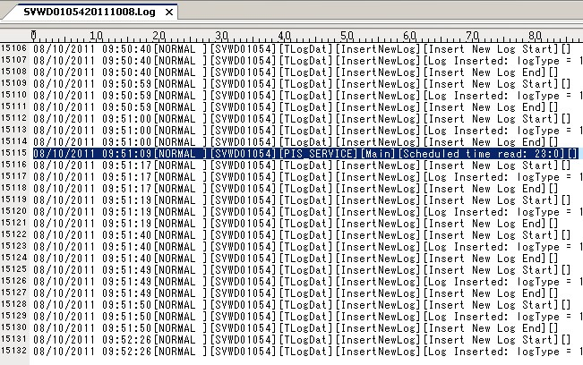  From image, last log message of PIS_SERVICE on 2011/10/08 occurred at 09:51:09.  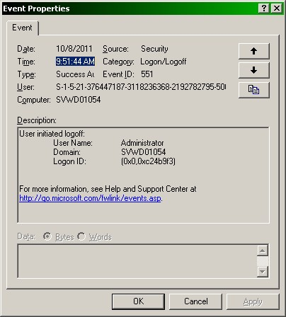  From event log, there is system logoff on 09:51:44, so the service is stopped and no more log of PIS_SERVICE.
Relation
Solution | Change startup method of PIS_SERVICE, from using Registry to adding the service to windows service and set startup type to Automatic.
Document
Remarks

